# Supporting information (SI) to

Single-step genome-wide association for selected milk fatty acids in Dual-Purpose Belgian Blue cows

H. Atashi1,2, Y. Chen1, H. Wilmot1,3, S. Vanderick1, X. Hubin4, H. Soyeurt1, N. Gengler1

1 TERRA Teaching and Research Center, Gembloux Agro-Bio Tech, University of Liège, 5030 Gembloux, Belgium.

2 Department of Animal Science, Shiraz University, 71441-13131 Shiraz, Iran.

3 National Fund for Scientific Research (F.R.S.-FNRS), Rue d’Egmont 5, B-1000 Brussels, Belgium

4 Elevéo asbl Awé Group, 5590 Ciney, Belgium

Table S1. Accuracy of mid-infrared predictions for fatty acid (FA) in milk (g/dl of milk)1 reported by Soyeurt et al. (2011)

|  |  |  |  |  |  |
| --- | --- | --- | --- | --- | --- |
| Constituent  (g/dl of milk) | Mean | SD | SECV | R2cv | RPD |
| Fat | 3.650 | 1.150 | 0.04 | 1.00 | 25.6 |
| C4:0 | 0.100 | 0.030 | 0.01 | 0.89 | 3.0 |
| C6:0 | 0.067 | 0.024 | 0.01 | 0.95 | 4.3 |
| C8:0 | 0.042 | 0.016 | 0.00 | 0.93 | 3.8 |
| C10:0 | 0.100 | 0.040 | 0.01 | 0.92 | 3.6 |
| C12:0 | 0.120 | 0.050 | 0.01 | 0.92 | 3.6 |
| C14:0 | 0.400 | 0.130 | 0.03 | 0.95 | 4.3 |
| C16:0 | 1.050 | 0.390 | 0.10 | 0.93 | 3.8 |
| C18:0 | 0.380 | 0.180 | 0.06 | 0.88 | 2.8 |
| C18:1 *trans* | 0.140 | 0.070 | 0.03 | 0.84 | 2.5 |
| C18:1 *cis*-9 | 0.740 | 0.290 | 0.06 | 0.95 | 4.5 |
| Saturated FA | 2.420 | 0.820 | 0.08 | 0.99 | 10.8 |
| Monounsaturated FA | 1.060 | 0.370 | 0.06 | 0.97 | 5.8 |
| Polyunsaturated FA | 0.160 | 0.050 | 0.02 | 0.81 | 2.3 |
| Short-chain FA | 0.320 | 0.110 | 0.02 | 0.95 | 4.5 |
| Medium-chain FA | 1.800 | 0.620 | 0.12 | 0.96 | 5.1 |
| Long-chain FA | 1.530 | 0.570 | 0.12 | 0.96 | 4.8 |

1SECV = standard error of cross-validation; R2cv = cross-validation coefficient of determination; RPD = ratio of SD of GC data from the calibration set to the SECV.

Soyeurt, H., F. Dehareng, N. Gengler, S. McParland, E. Wall, D. Berry, M. Coffey, and P. Dardenne. 2011. Mid-infrared prediction of bovine milk fatty acids across multiple breeds, production systems, and countries. Journal of Dairy Science 94(4):1657-1667.

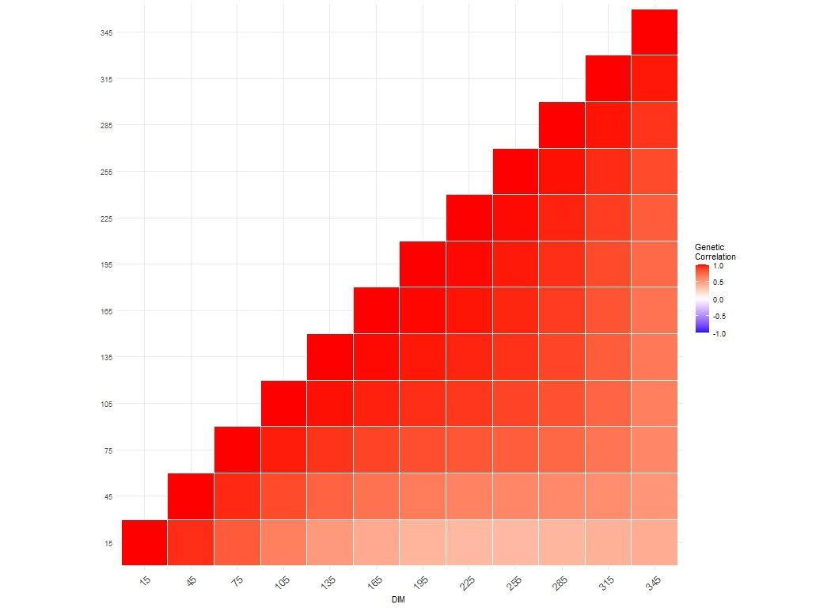

Figure S1. Heatmap of genetic correlation estimated among selected days in milk (DIM) for C4:0 in the first parity Dual-Purpose Belgian Blue cows

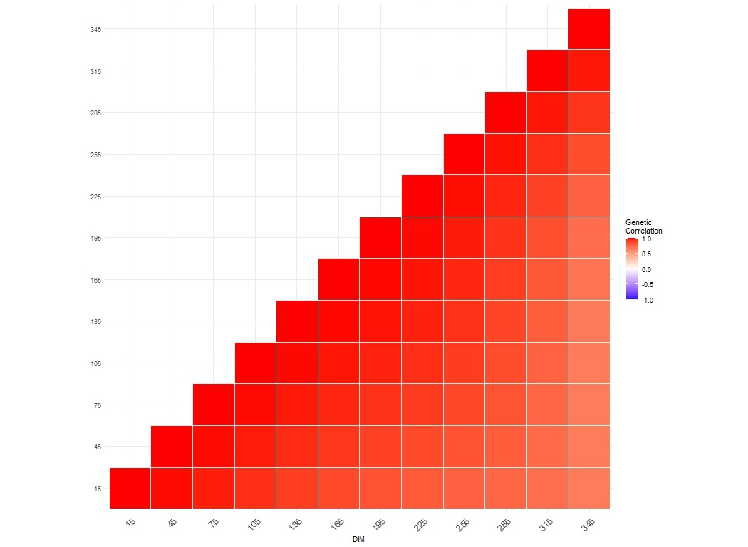

Figure S2. Heatmap of genetic correlation coefficients estimated among selected days in milk (DIM) for C4:0 in the second parity Dual-Purpose Belgian Blue cows

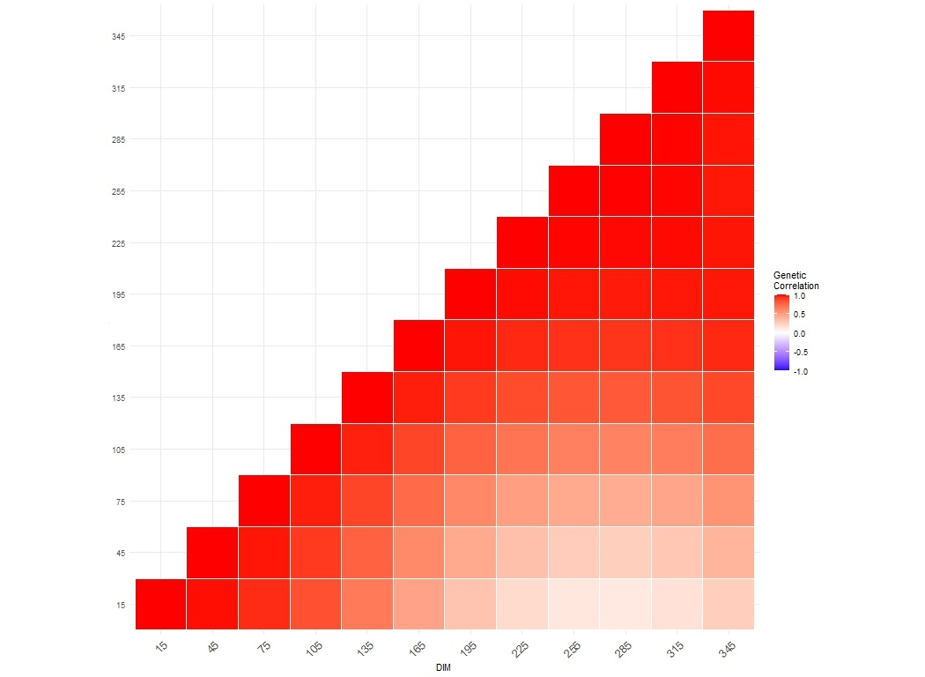

Figure S3. Heatmap of genetic correlation coefficients estimated among selected days in milk (DIM) for C6:0 in the first parity Dual-Purpose Belgian Blue cows

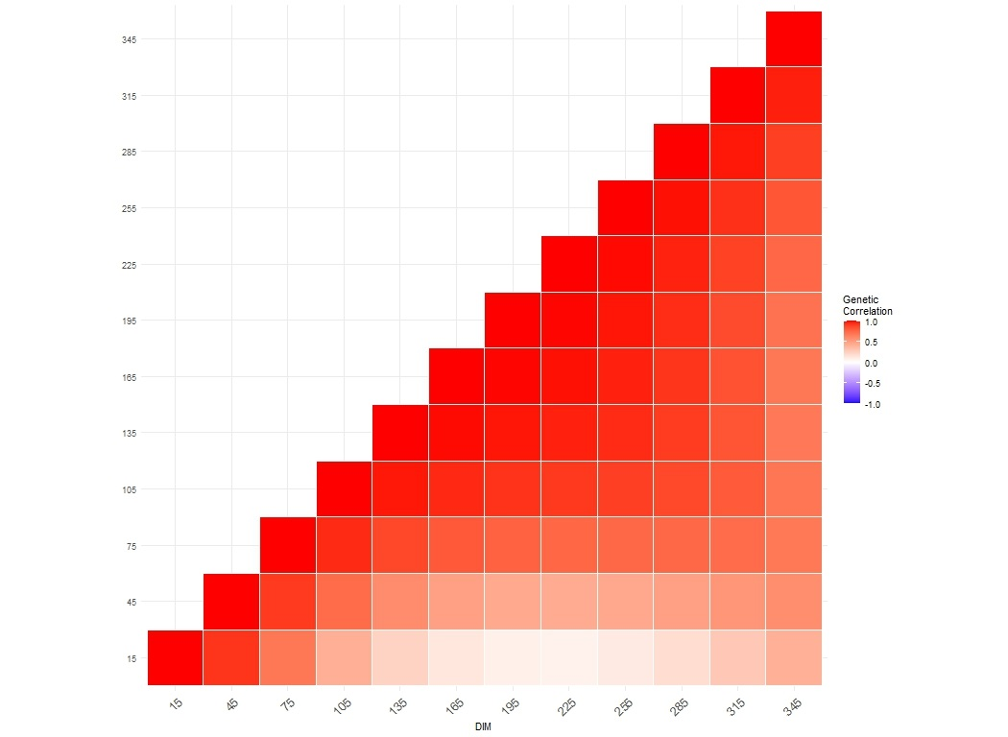

Figure S4. Heatmap of genetic correlation coefficients estimated among selected days in milk (DIM) for C6:0 in the second parity Dual-Purpose Belgian Blue cows

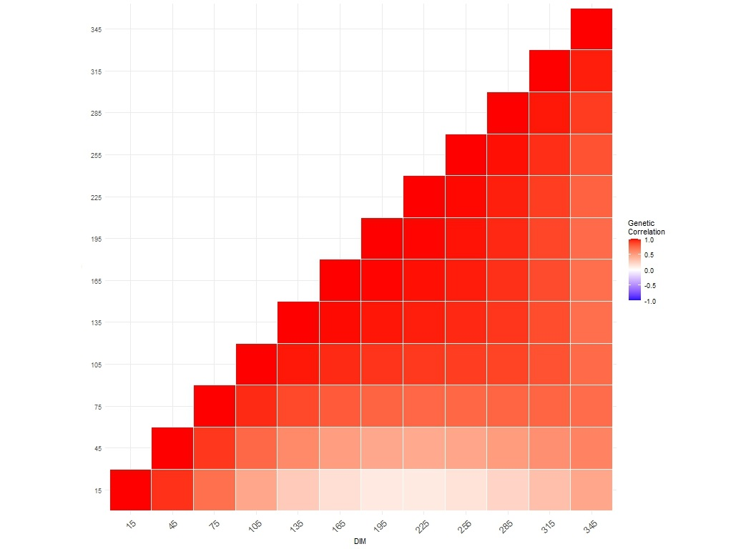

Figure S5. Heatmap of genetic correlation coefficients estimated among selected days in milk (DIM) for C8:0 in the first parity Dual-Purpose Belgian Blue cows

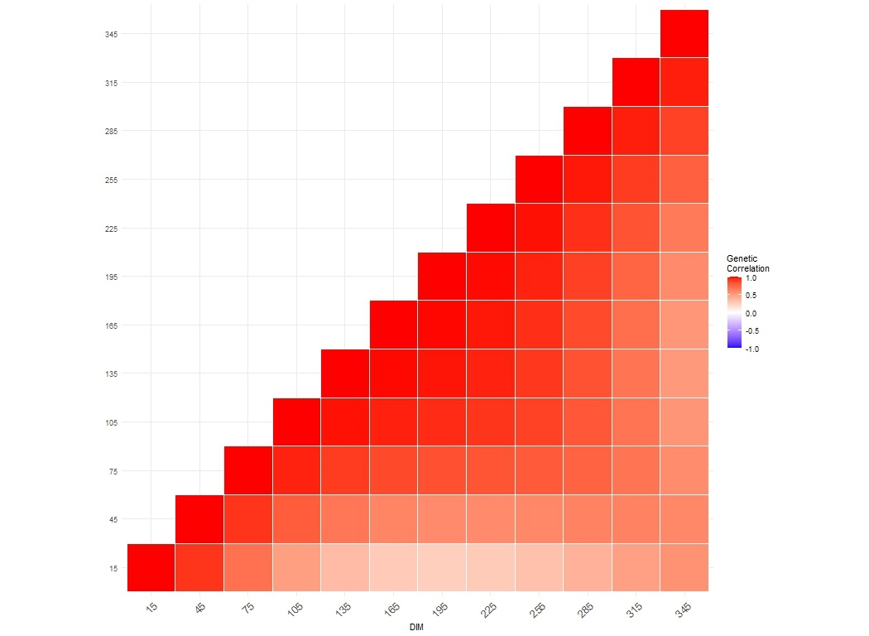

Figure S6. Heatmap of genetic correlation coefficients estimated among selected days in milk (DIM) for C8:0 in the second parity Dual-Purpose Belgian Blue cows

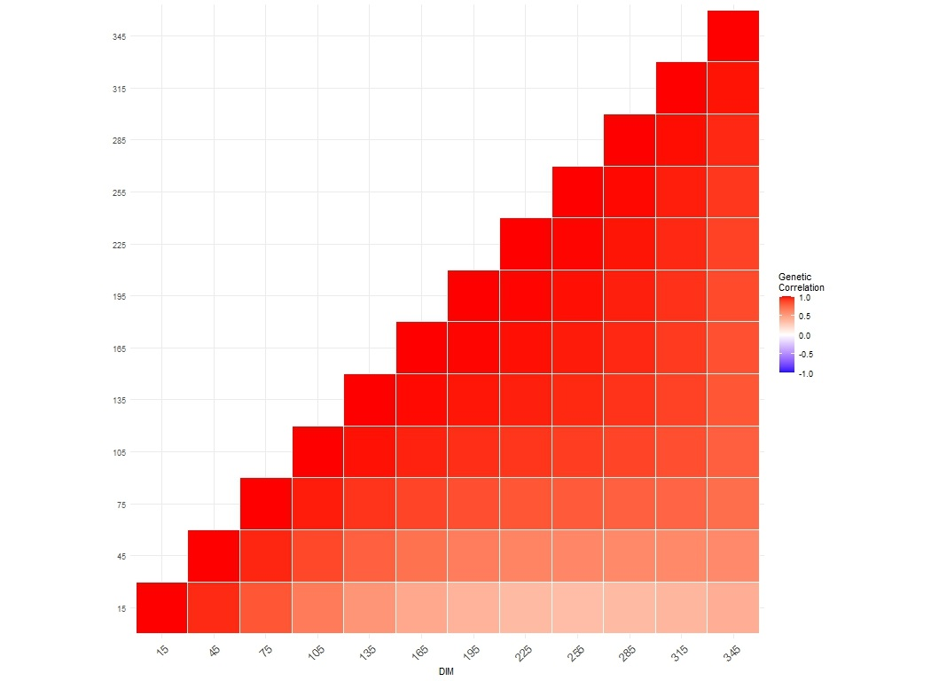

Figure S7. Heatmap of genetic correlation coefficients estimated among selected days in milk (DIM) for C10:0 in the first parity Dual-Purpose Belgian Blue cows

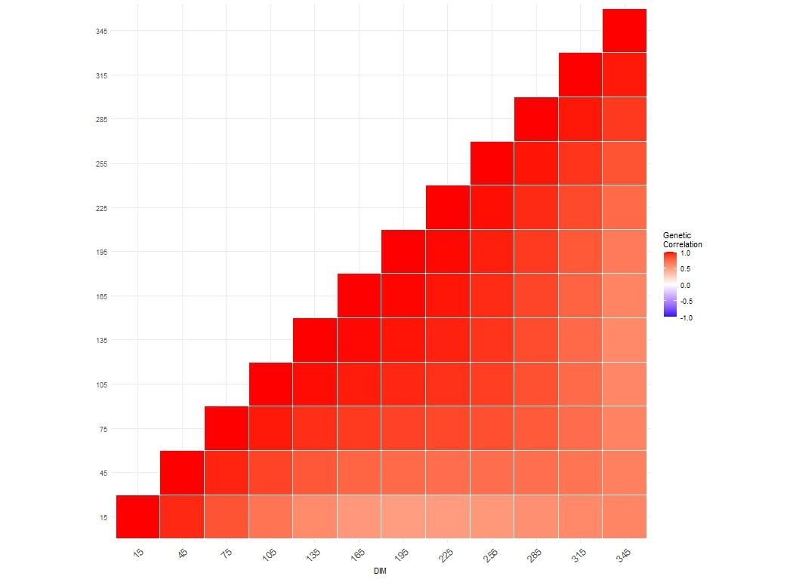

Figure S8. Heatmap of genetic correlation coefficients estimated among selected days in milk (DIM) for C10:0 in the second parity Dual-Purpose Belgian Blue cows

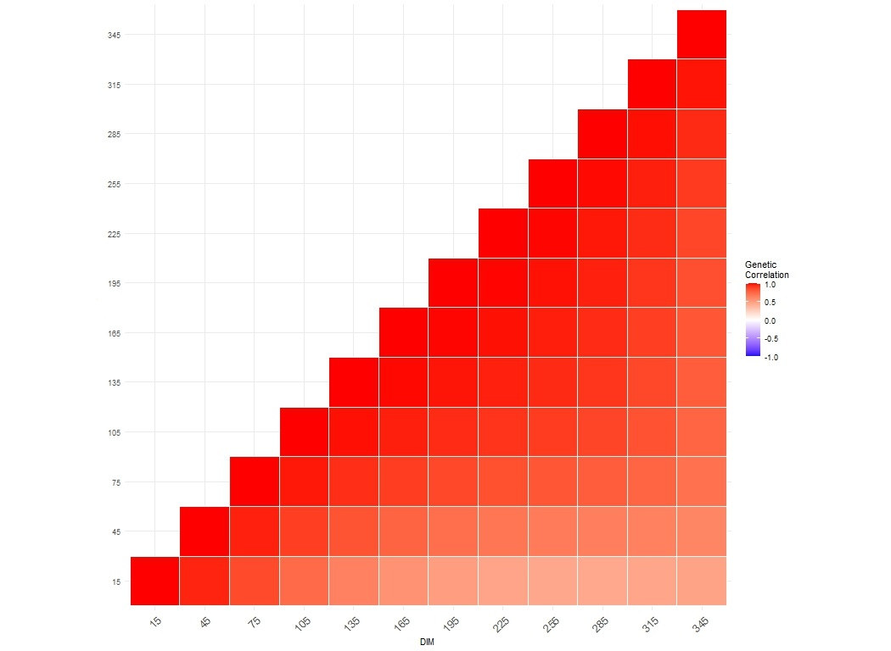

Figure S9. Heatmap of genetic correlation coefficients estimated among selected days in milk (DIM) for C12:0 in the first parity Dual-Purpose Belgian Blue cows

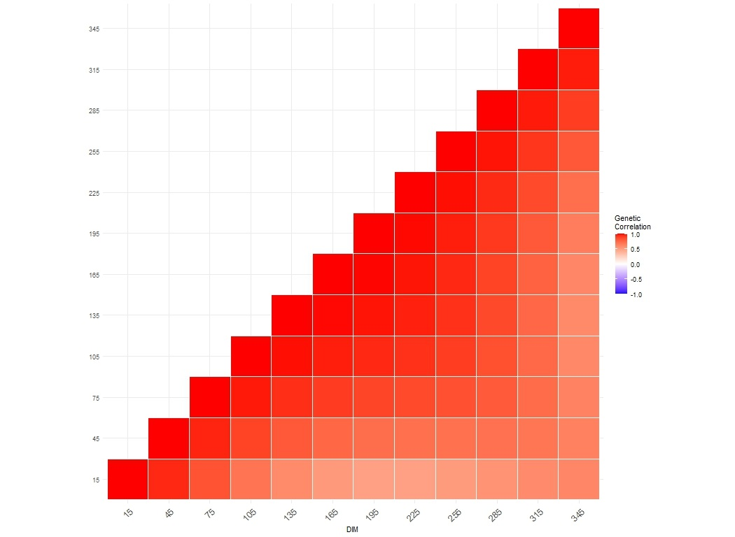

Figure S10. Heatmap of genetic correlation coefficients estimated among selected days in milk (DIM) for C12:0 in the second parity Dual-Purpose Belgian Blue cows

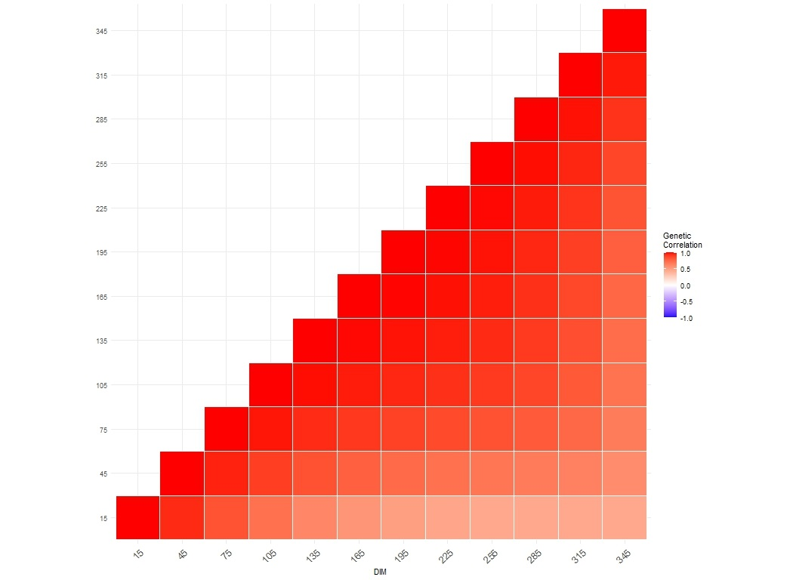

Figure S11. Heatmap of genetic correlation coefficients estimated among selected days in milk (DIM) for C14:0 in the first parity Dual-Purpose Belgian Blue cows

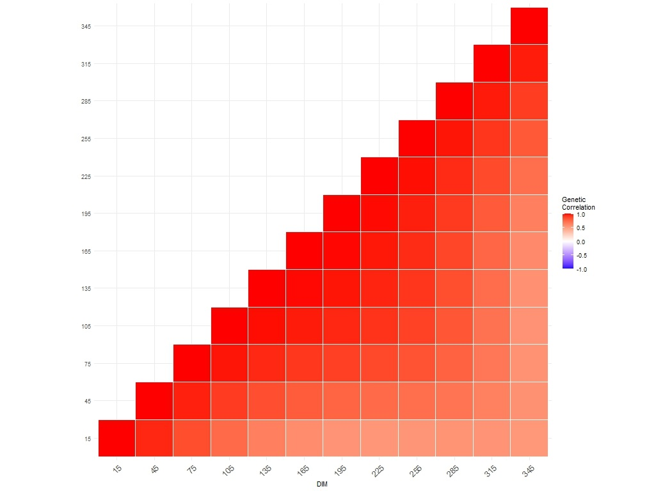

Figure S12. Heatmap of genetic correlation coefficients estimated among selected days in milk (DIM) for C14:0 in the second parity Dual-Purpose Belgian Blue cows

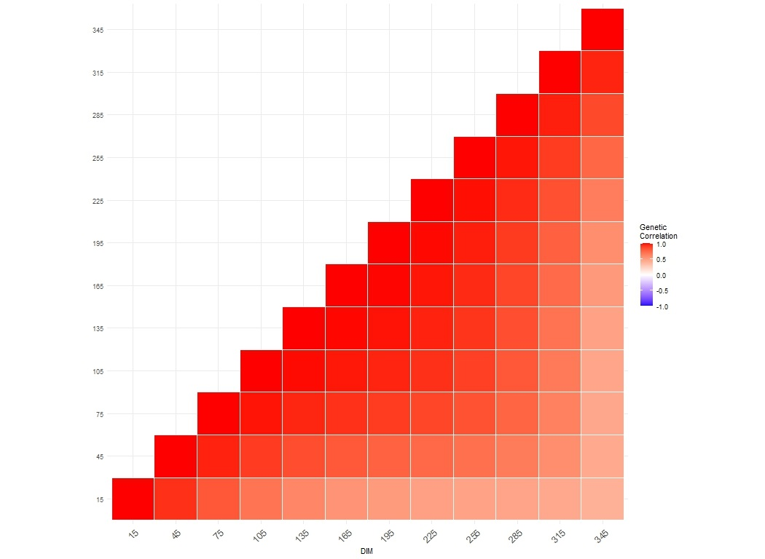

Figure S13. Heatmap of genetic correlation coefficients estimated among selected days in milk (DIM) for C16:0 in the first parity Dual-Purpose Belgian Blue cows

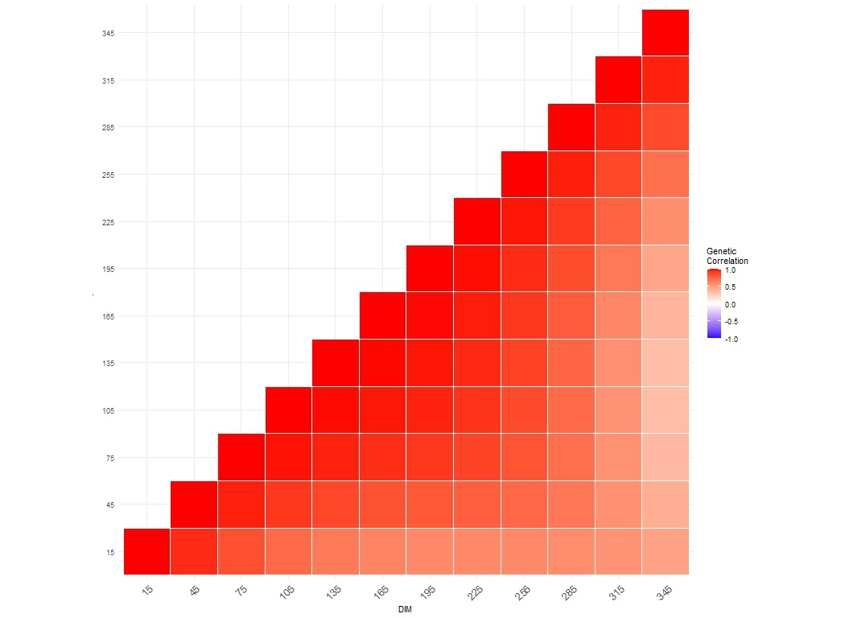

Figure S14. Heatmap of genetic correlation coefficients estimated among selected days in milk (DIM) for C16:0 in the second parity Dual-Purpose Belgian Blue cows

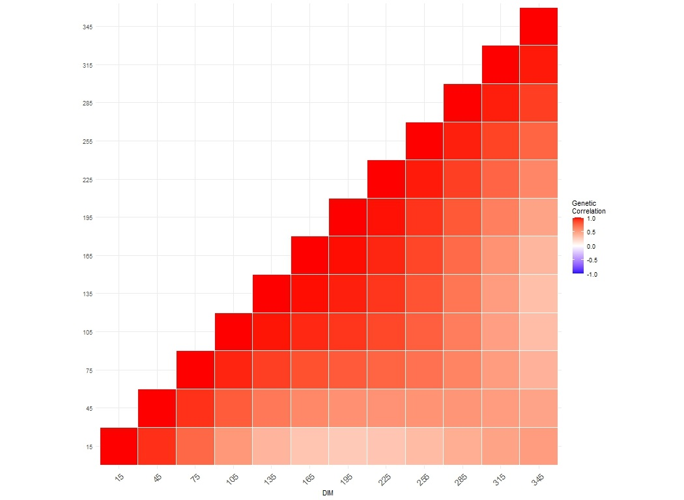

Figure S15. Heatmap of genetic correlation coefficients estimated among selected days in milk (DIM) for C18:0 in the first parity Dual-Purpose Belgian Blue cows

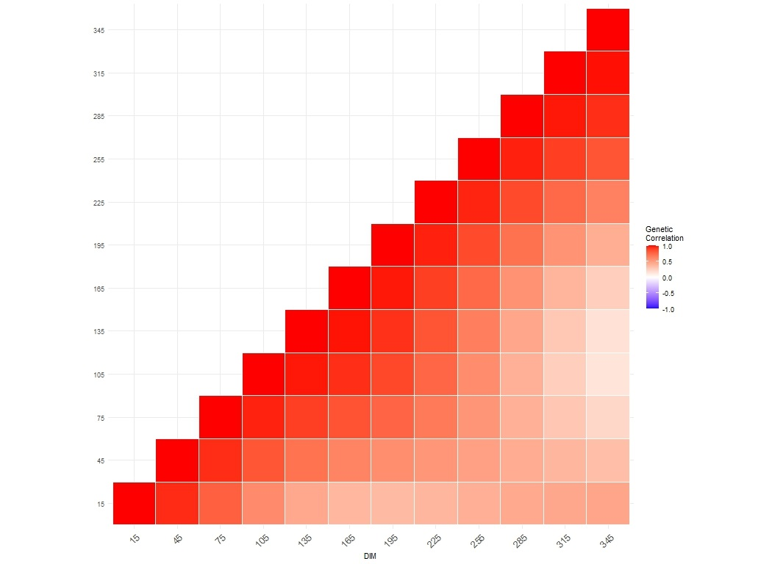

Figure S16. Heatmap of genetic correlation coefficients estimated among selected days in milk (DIM) for C18:0 in the second parity Dual-Purpose Belgian Blue cows

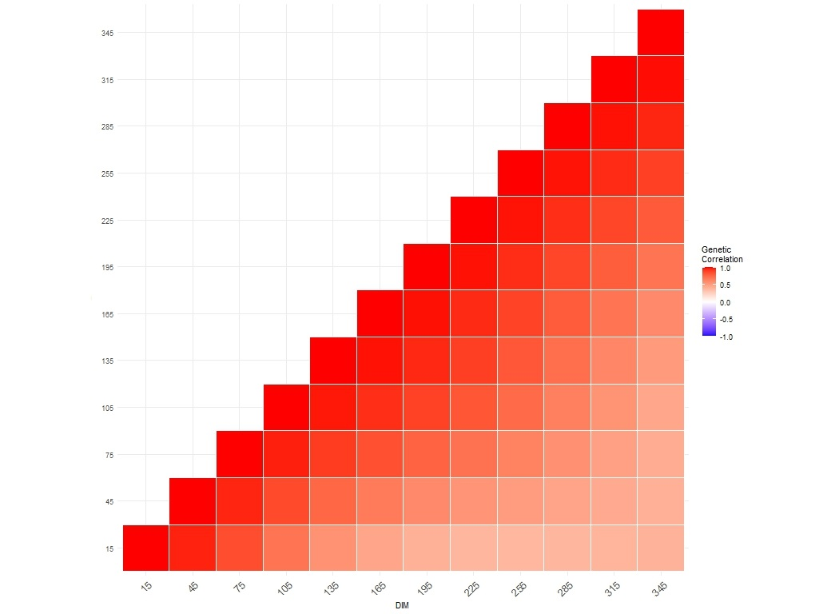

Figure S17. Heatmap of genetic correlation coefficients estimated among selected days in milk (DIM) for C18:1 *trans* in the first parity Dual-Purpose Belgian Blue cows

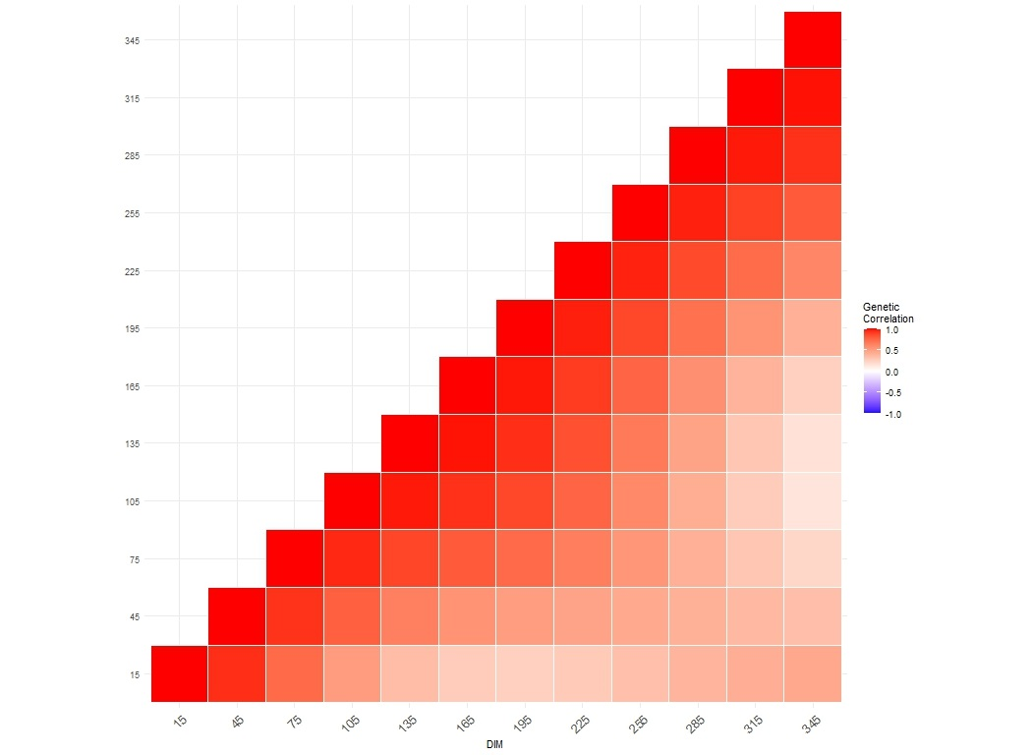

Figure S18. Heatmap of genetic correlation coefficients estimated among selected days in milk (DIM) for C18:1 trans in the second parity Dual-Purpose Belgian Blue cows

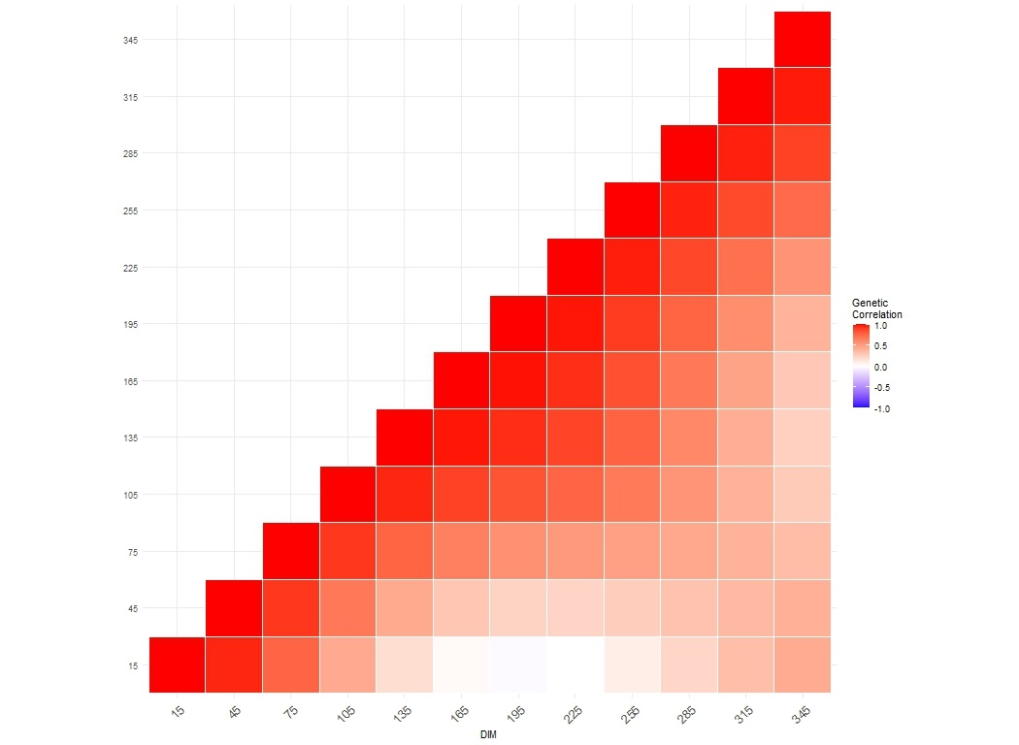

Figure S19. Heatmap of genetic correlation coefficients estimated among selected days in milk (DIM) for C18:1 *cis*-9 in the first parity Dual-Purpose Belgian Blue cows

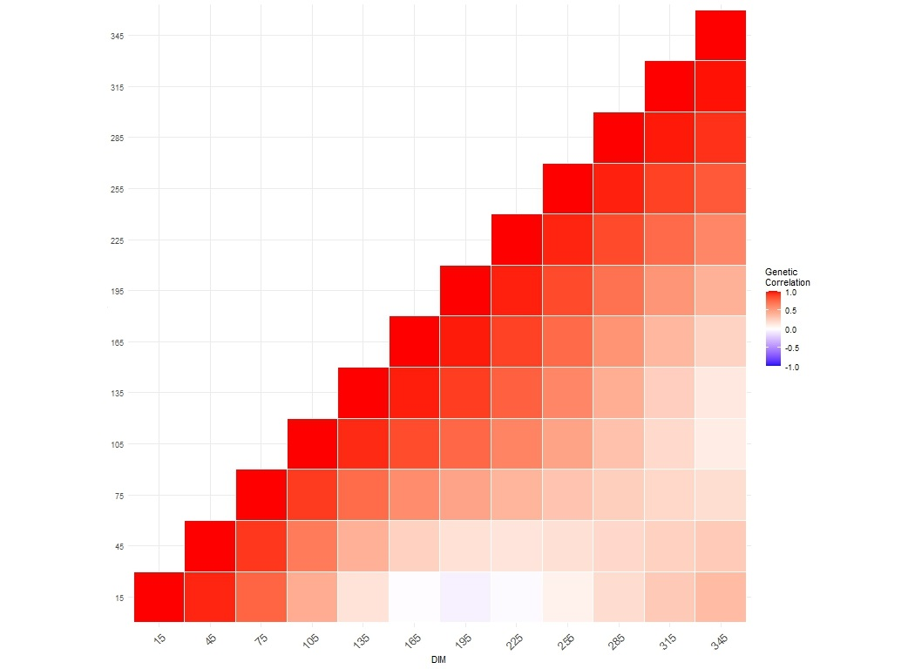

Figure S20. Heatmap of genetic correlation coefficients estimated among selected days in milk (DIM) for C18:1 *cis*-9 in the second parity Dual-Purpose Belgian Blue cows

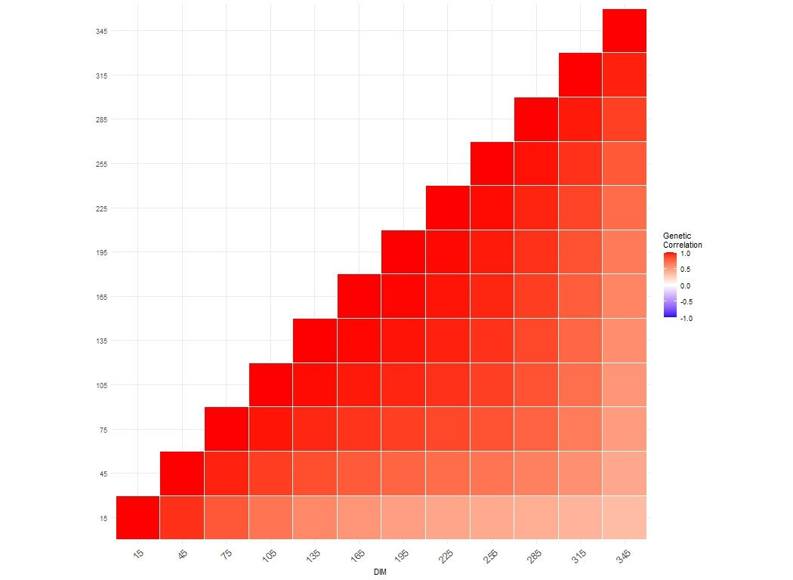

Figure S21. Heatmap of genetic correlation coefficients estimated among selected days in milk (DIM) for saturated fatty acids (SFA) in the first parity Dual-Purpose Belgian Blue cows

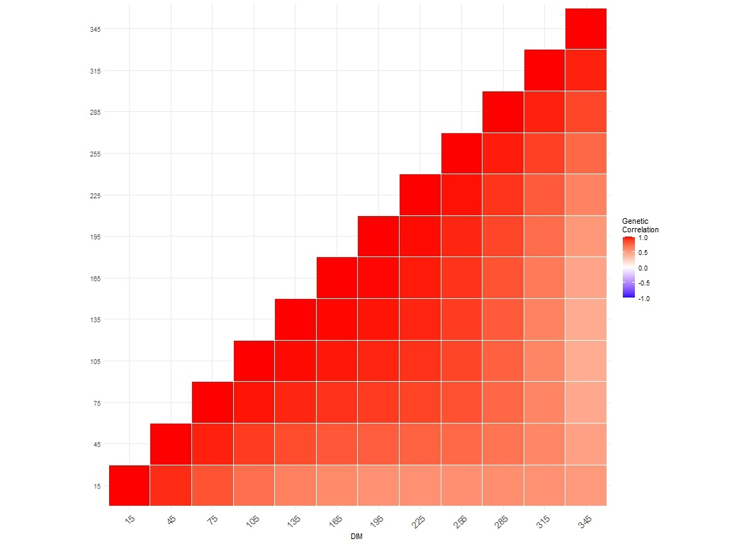

Figure S22. Heatmap of genetic correlation coefficients estimated among selected days in milk (DIM) for saturated fatty acids (SFA) in the second parity Dual-Purpose Belgian Blue cows

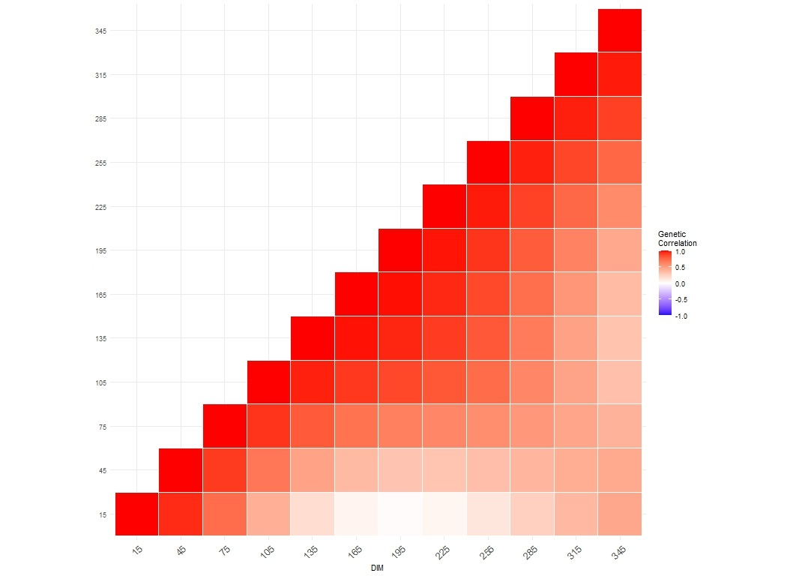

Figure S23. Heatmap of genetic correlation coefficients estimated among selected days in milk (DIM) for monounsaturated fatty acids (MUFA) in the first parity Dual-Purpose Belgian Blue cows

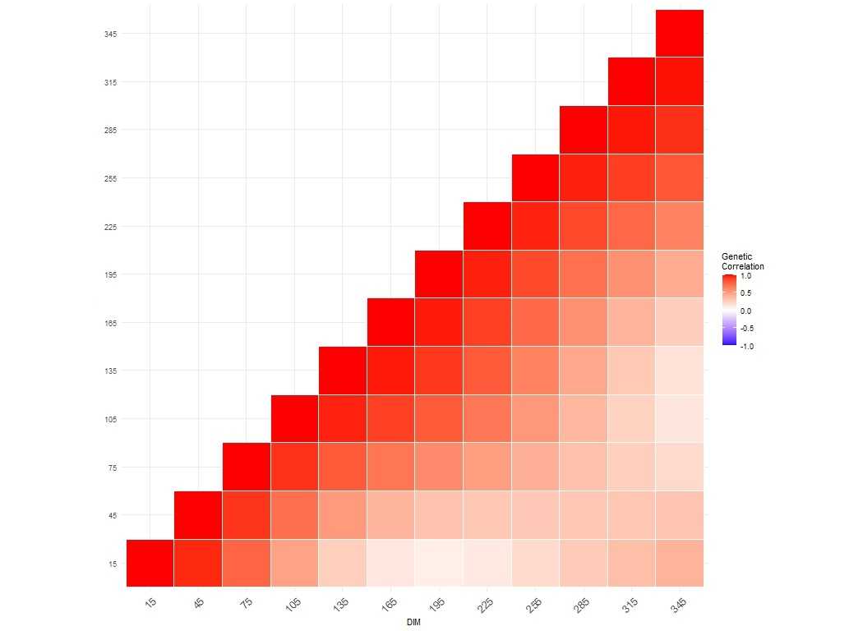

Figure S24. Heatmap of genetic correlation coefficients estimated among selected days in milk (DIM) for monounsaturated fatty acids (MUFA) in the second parity Dual-Purpose Belgian Blue cows

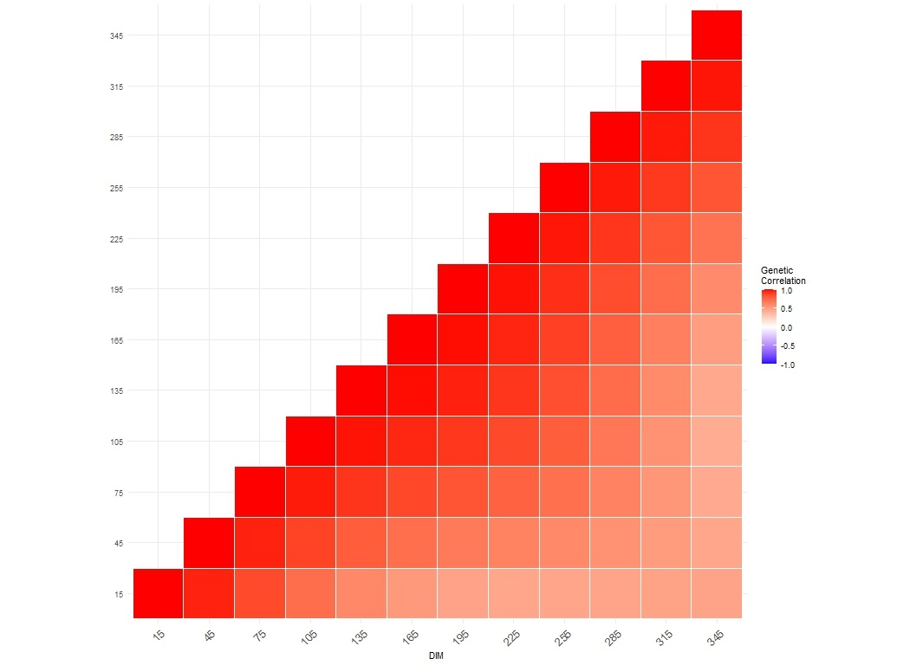

Figure S25. Heatmap of genetic correlation coefficients estimated among selected days in milk (DIM) for polyunsaturated fatty acids (PUFA) in the first parity Dual-Purpose Belgian Blue cows

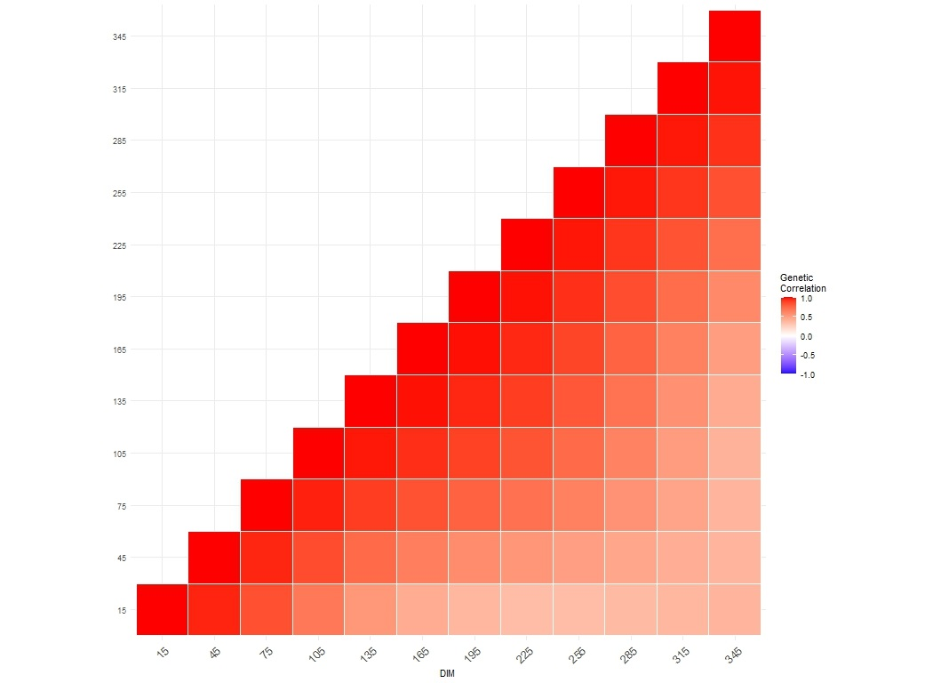

Figure S26. Heatmap of genetic correlation coefficients estimated among selected days in milk (DIM) for polyunsaturated fatty acids (PUFA) 9 in the second parity Dual-Purpose Belgian Blue cows

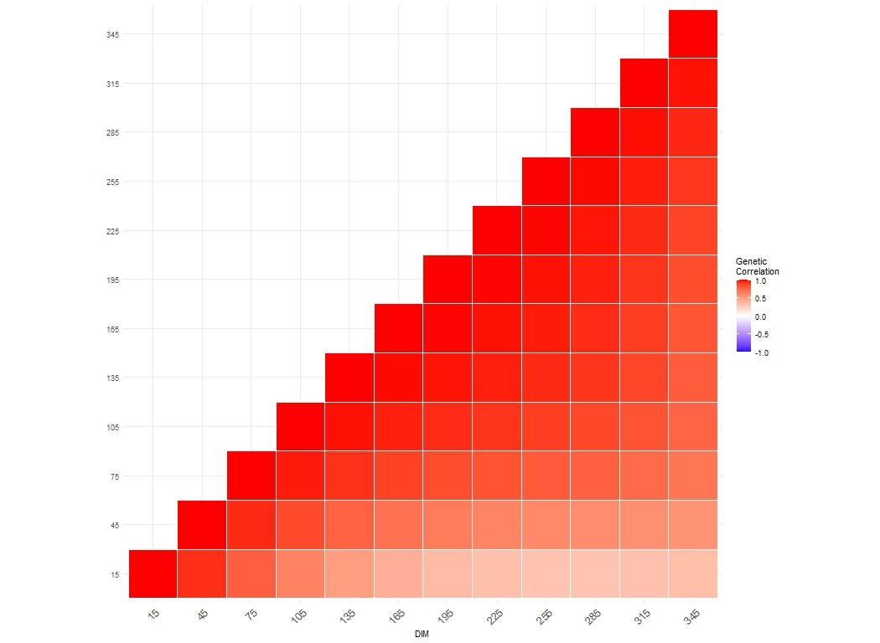

Figure S27. Heatmap of genetic correlation coefficients estimated among selected days in milk (DIM) for short-chain fatty acids (SCFA) in the first parity Dual-Purpose Belgian Blue cows

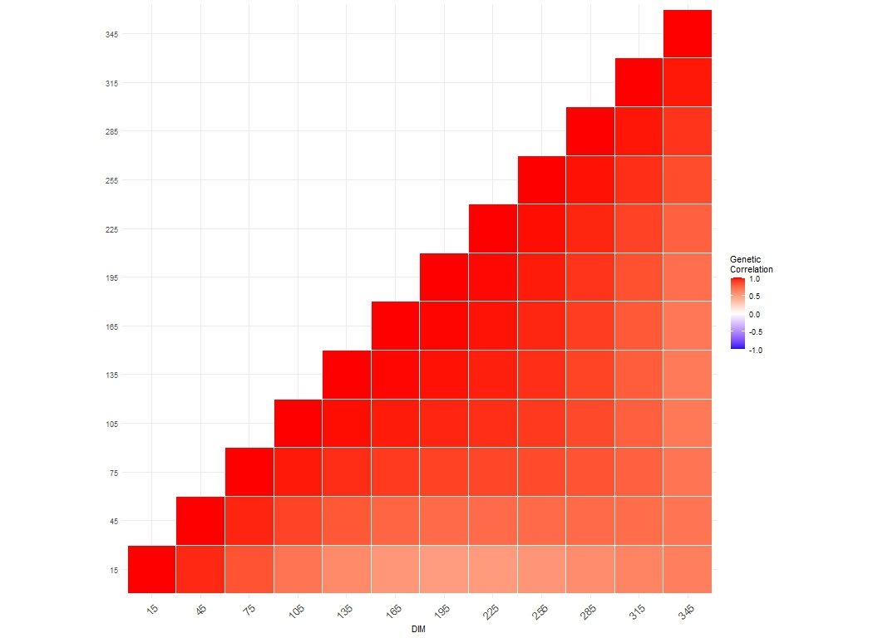

Figure S28. Heatmap of genetic correlation coefficients estimated among selected days in milk (DIM) for short-chain fatty acids (SCFA) in the second parity Dual-Purpose Belgian Blue cows

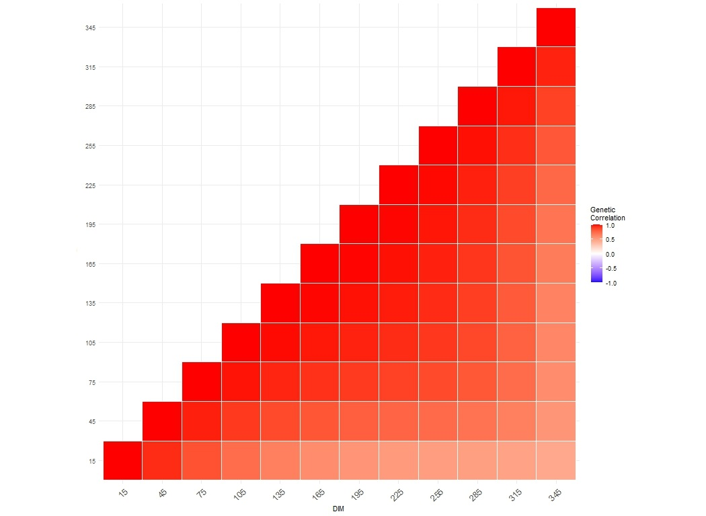

Figure S29. Heatmap of genetic correlation coefficients estimated among selected days in milk (DIM) for medium-chain fatty acids (MCFA) in the first parity Dual-Purpose Belgian Blue cows

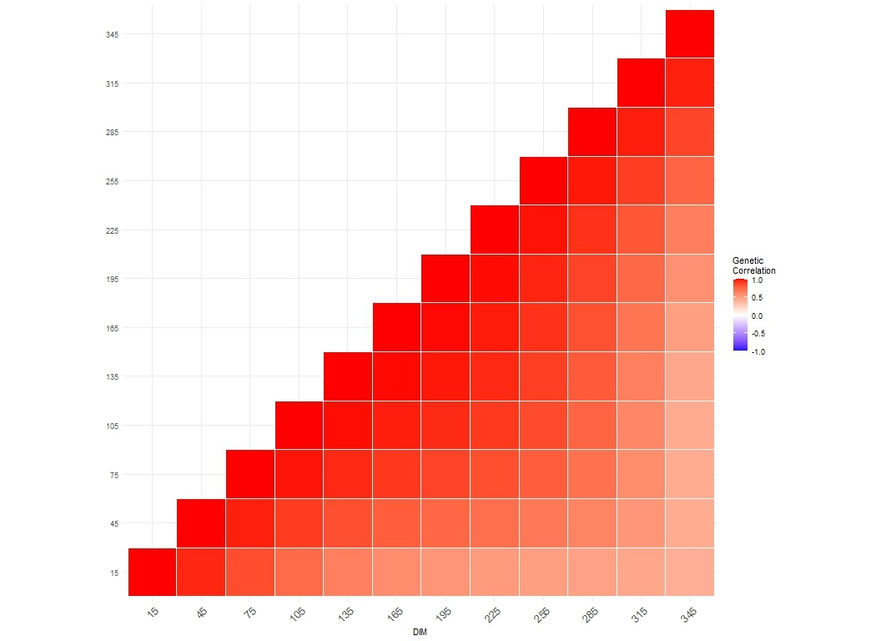

Figure S30. Heatmap of genetic correlation coefficients estimated among selected days in milk (DIM) for medium-chain fatty acids (MCFA) in the second parity Dual-Purpose Belgian Blue cows

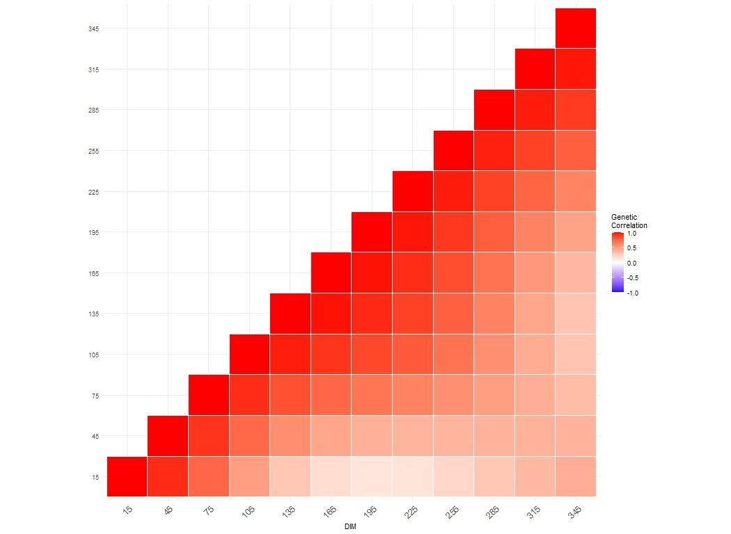

Figure S31. Heatmap of genetic correlation coefficients estimated among selected days in milk (DIM) for long-chain fatty acids (LCFA) in the first parity Dual-Purpose Belgian Blue cows

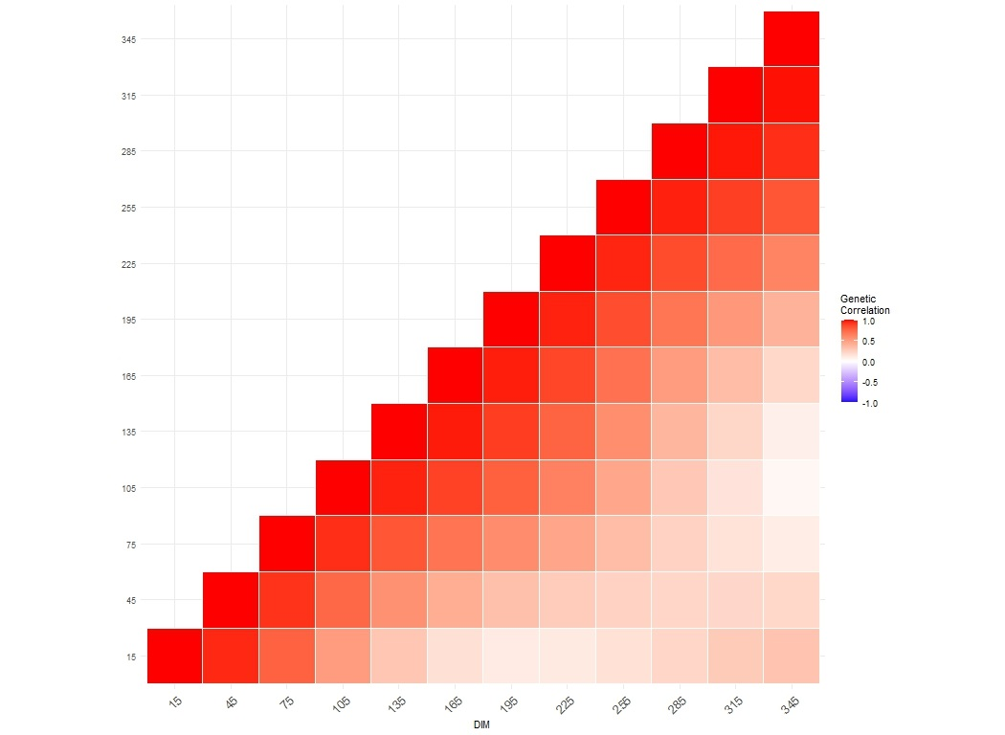

Figure S32. Heatmap of genetic correlation coefficients estimated among selected days in milk (DIM) for long-chain fatty acids (LCFA) in the second parity Dual-Purpose Belgian Blue cows

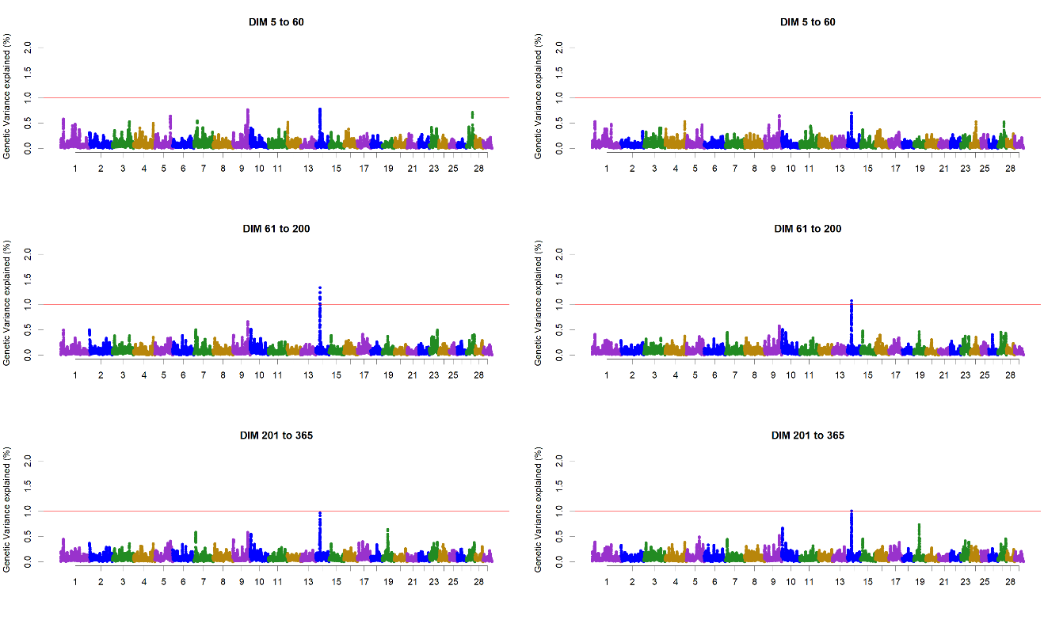

Figure S33. Additive genetic variance explained by windows of 25 adjacent SNPs across chromosomes for C4:0 in different stages of lactation in the first (left) and second parity (right) Dual-Purpose Belgian Blue cows

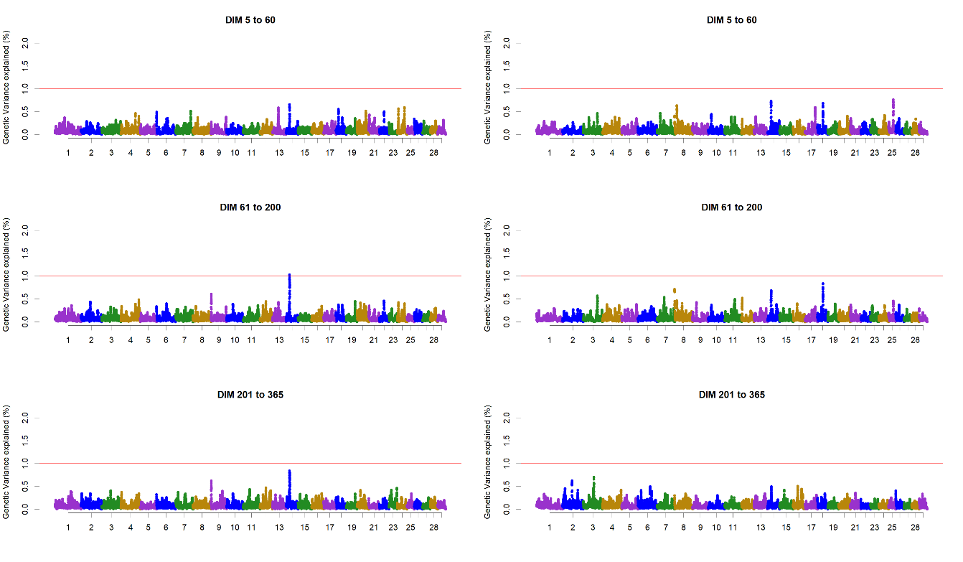

Figure S34. Additive genetic variance explained by windows of 25 adjacent SNPs across chromosomes for C6:0 in different stages of lactation in the first (left) and second parity (right) Dual-Purpose Belgian Blue cows

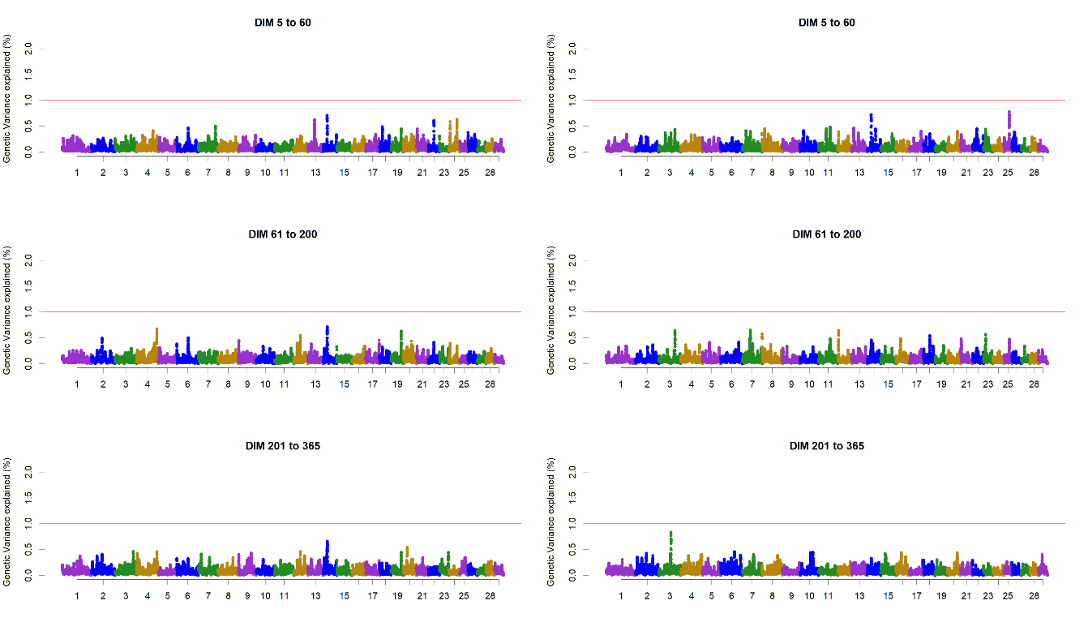

Figure S35. Additive genetic variance explained by windows of 25 adjacent SNPs across chromosomes for C8:0 in different stages of lactation in the first (left) and second parity (right) Dual-Purpose Belgian Blue cows

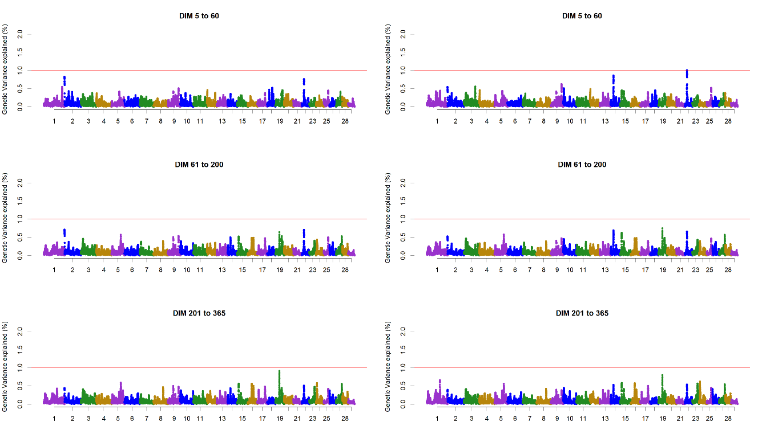

Figure S36. Additive genetic variance explained by windows of 25 adjacent SNPs across chromosomes for C10:0 in different stages of lactation in the first (left) and second parity (right) Dual-Purpose Belgian Blue cows

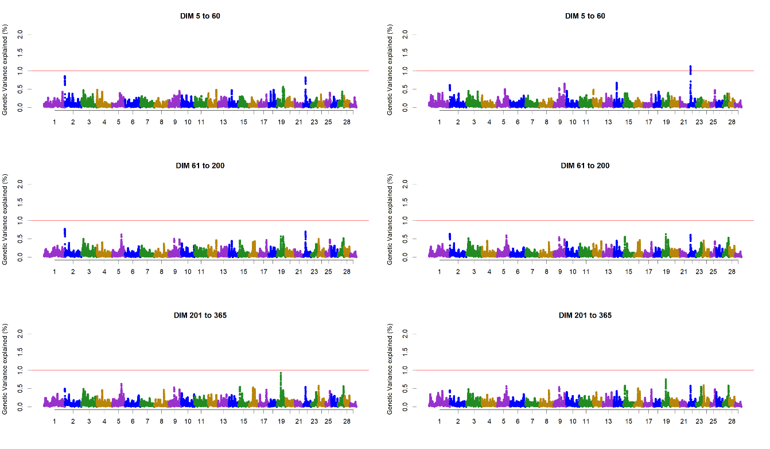

Figure S37 Additive genetic variance explained by windows of 25 adjacent SNPs across chromosomes for C12:0 in different stages of lactation in the first (left) and second parity (right) Dual-Purpose Belgian Blue cows

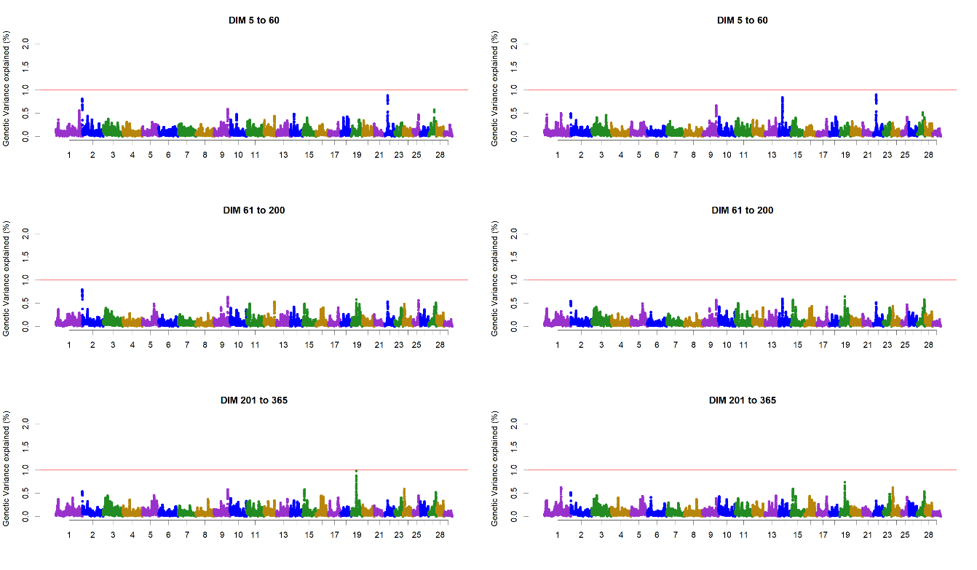

Figure S38. Additive genetic variance explained by windows of 25 adjacent SNPs across chromosomes for C14:0 in different stages of lactation in the first (left) and second parity (right) Dual-Purpose Belgian Blue cows

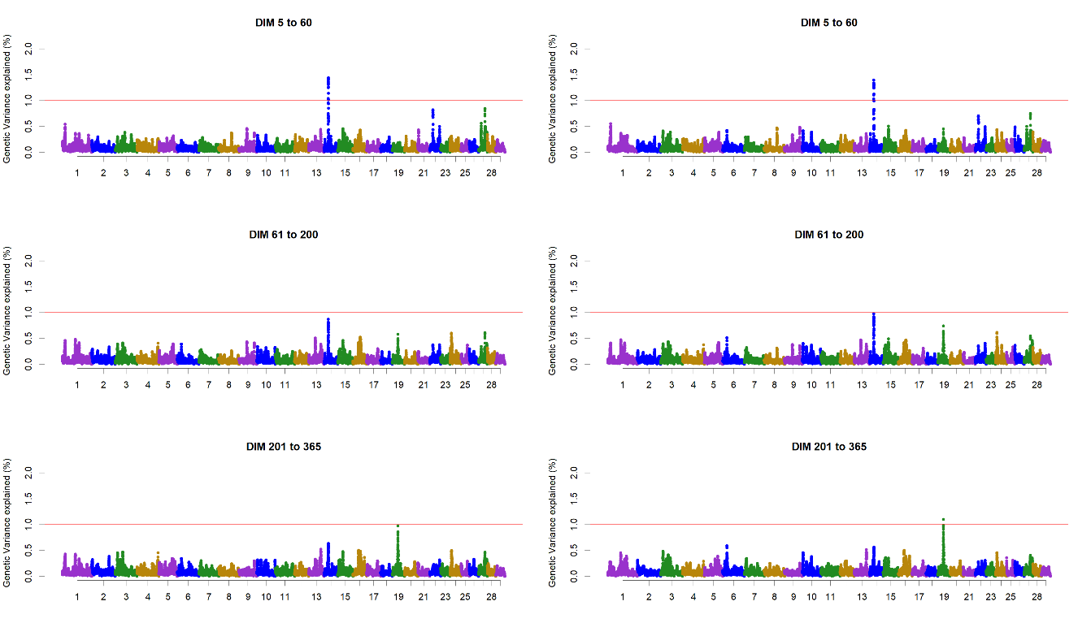

Figure S39. Additive genetic variance explained by windows of 25 adjacent SNPs across chromosomes for C16:0 in different stages of lactation in the first (left) and second parity (right) Dual-Purpose Belgian Blue cows

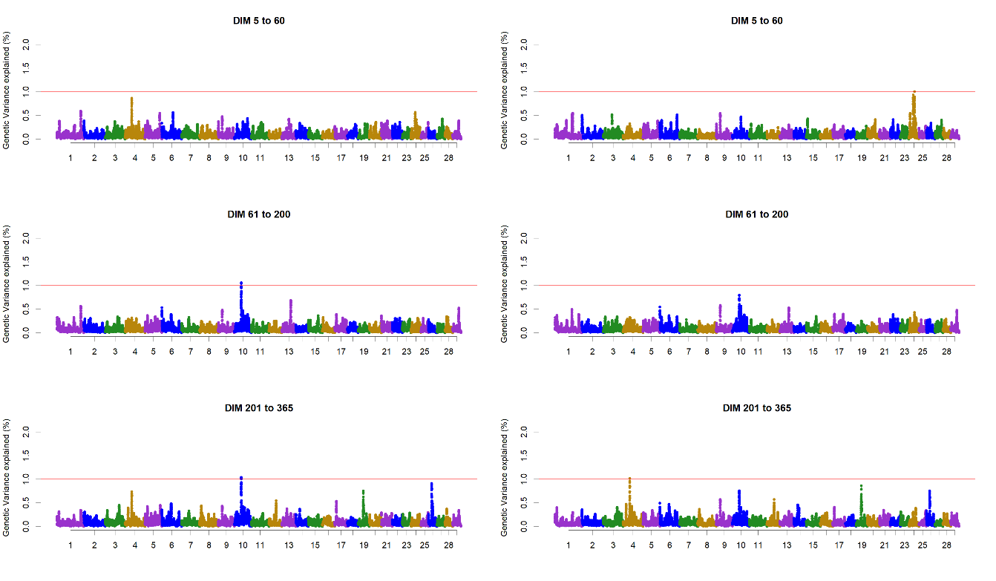

Figure S40. Additive genetic variance explained by windows of 25 adjacent SNPs across chromosomes for C18:0 in different stages of lactation in the first (left) and second parity (right) Dual-Purpose Belgian Blue cows

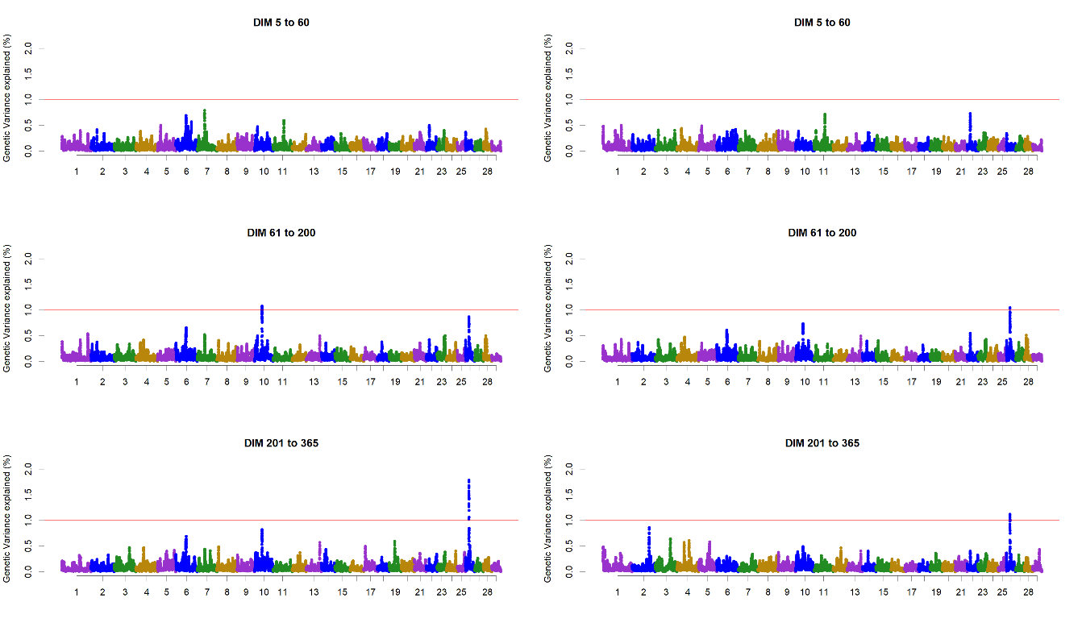

Figure S41. Additive genetic variance explained by windows of 25 adjacent SNPs across chromosomes for C18:1 *trans* in different stages of lactation in the first (left) and second parity (right) Dual-Purpose Belgian Blue cows

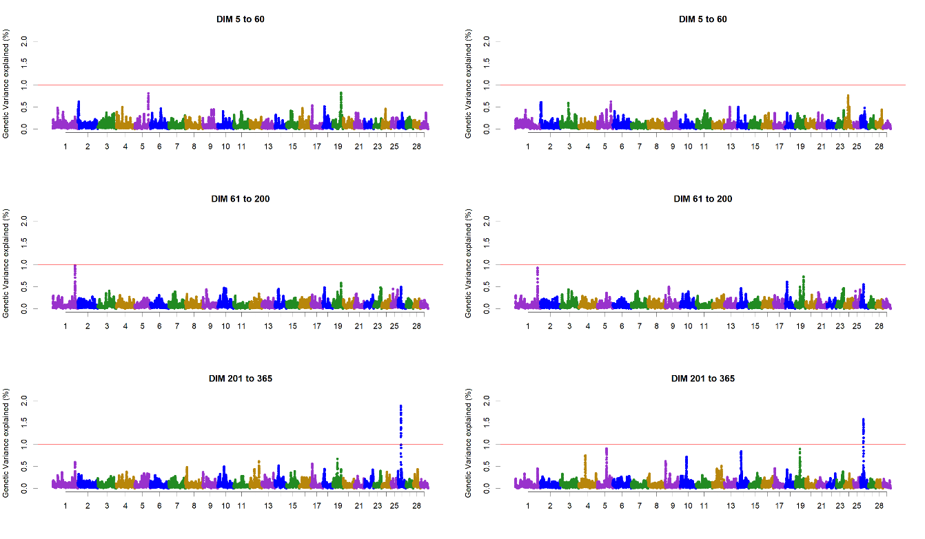

Figure S42. Additive genetic variance explained by windows of 25 adjacent SNPs across chromosomes for C18:1 *cis*-9 in different stages of lactation in the first (left) and second parity (right) Dual-Purpose Belgian Blue cows

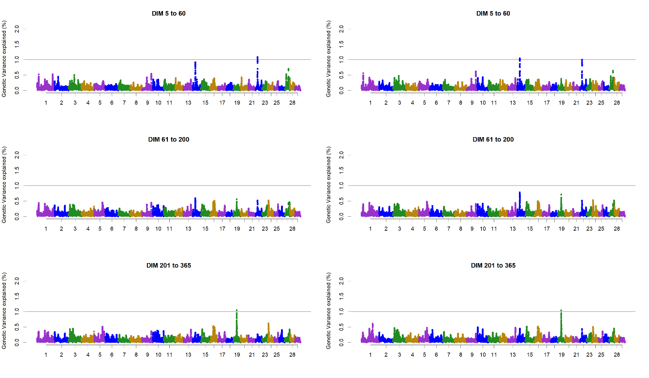

Figure S43. Additive genetic variance explained by windows of 25 adjacent SNPs across chromosomes for saturated fatty acids (SFA) in different stages of lactation in the first (left) and second parity (right) Dual-Purpose Belgian Blue cows

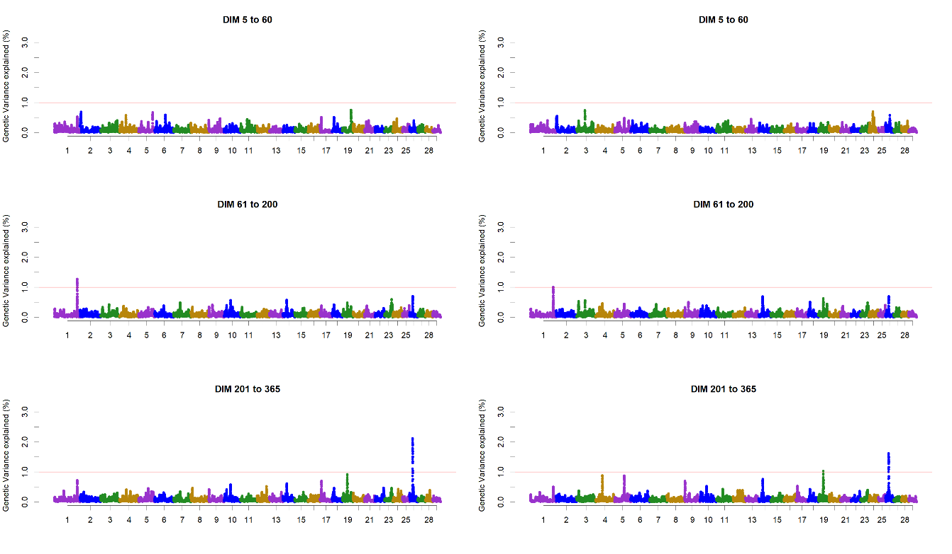

Figure S44. Additive genetic variance explained by windows of 25 adjacent SNPs across chromosomes for monounsaturated fatty acids (MUFA) in different stages of lactation in the first (left) and second parity (right) Dual-Purpose Belgian Blue cows

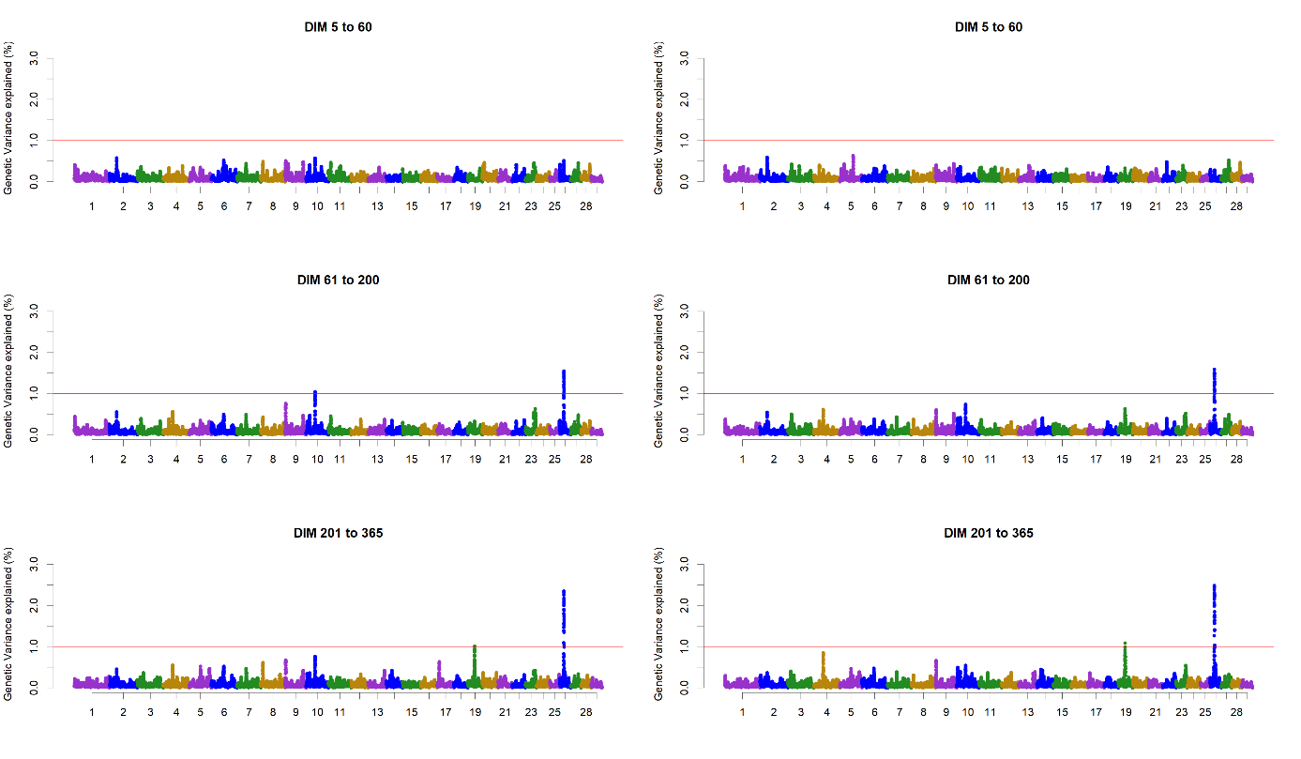

Figure S45. Additive genetic variance explained by windows of 25 adjacent SNPs across chromosomes for polyunsaturated fatty acids (PUFA) in different stages of lactation in the first (left) and second parity (right) Dual-Purpose Belgian Blue cows

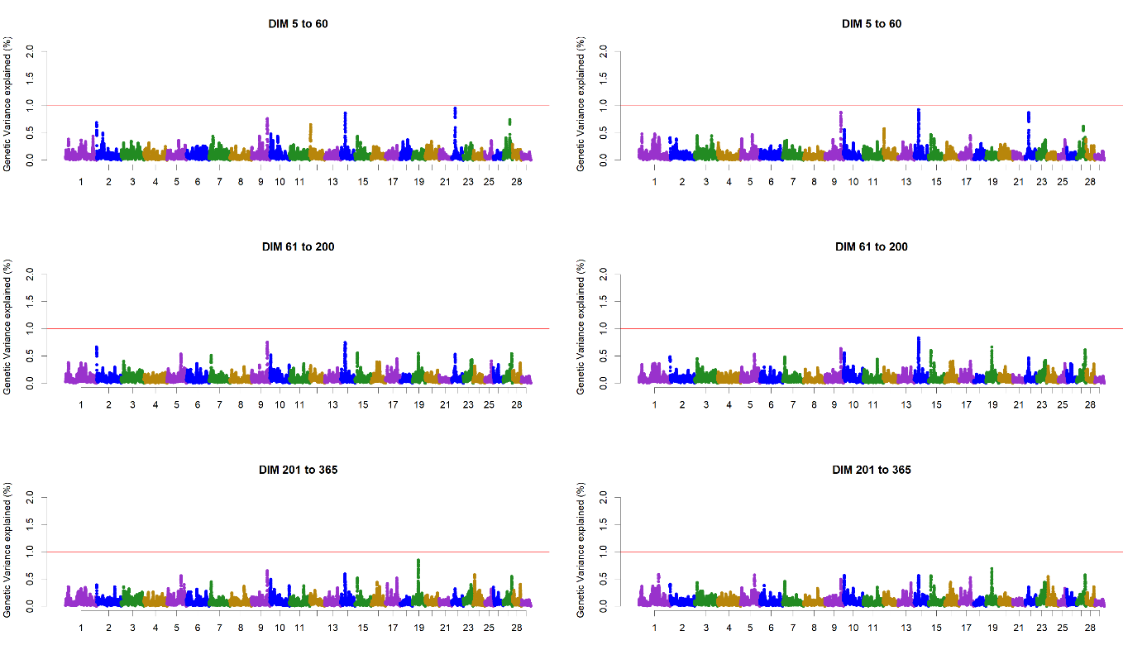

Figure S46. Additive genetic variance explained by windows of 25 adjacent SNPs across chromosomes for short-chain fatty acids (SCFA) in different stages of lactation in the first (left) and second parity (right) Dual-Purpose Belgian Blue cows

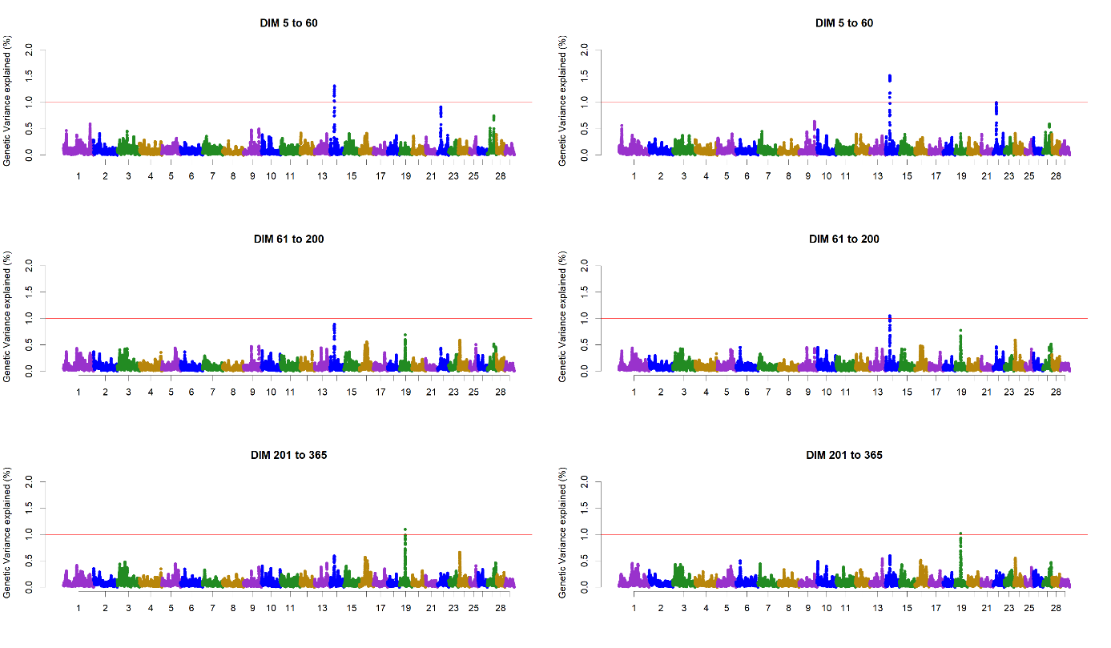

Figure S47. Additive genetic variance explained by windows of 25 adjacent SNPs across chromosomes for medium-chain fatty acids (MCFA) in different stages of lactation in the first (left) and second parity (right) Dual-Purpose Belgian Blue cows

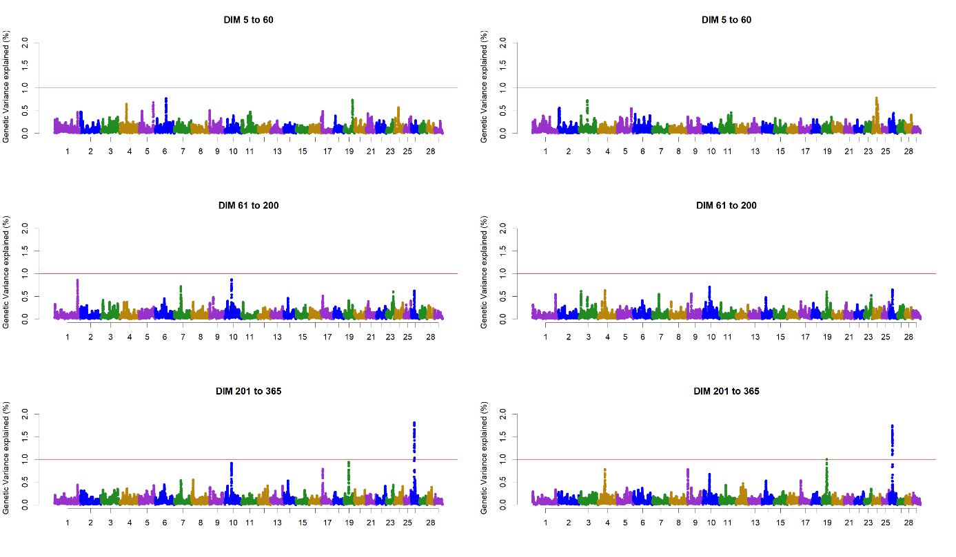

Figure S48. Additive genetic variance explained by windows of 25 adjacent SNPs across chromosomes for long-chain fatty acids (LCFA) in different stages of lactation in the first (left) and second parity (right) Dual-Purpose Belgian Blue cows.